# Lab 1

The goal of this lab is to build and test a night light circuit using an LED and a Light Dependent Resistor.

## [Image result for particle photon](https://www.google.com/url?sa=i&rct=j&q=&esrc=s&source=images&cd=&cad=rja&uact=8&ved=2ahUKEwj49ZCggsLaAhUL24MKHeT0CvMQjRx6BAgAEAU&url=https://www.seeedstudio.com/Particle-Photon-p-2527.html&psig=AOvVaw2GyAksMO7fUTrEVD1Z9NaQ&ust=1524078837631976)Step 1

Place the Photon microcontroller on the breadboard with the USB plug against the edge labeled 1.

## Step 2

[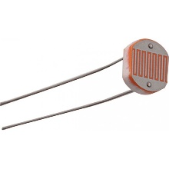](https://potentiallabs.com/cart/ldr-india)Insert one pin of the **Light Dependent Resistor** into position **A1** on the breadboard. Insert the other end of the LDR into **A12**. *This is a symmetric component, so it does not matter which way it is placed into the board.*

## Step 3

[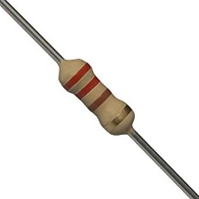](https://www.google.com/url?sa=i&rct=j&q=&esrc=s&source=images&cd=&cad=rja&uact=8&ved=2ahUKEwjDqebugcLaAhUO8YMKHQ1KD90QjRx6BAgAEAU&url=https://www.amazon.in/220-carbon-film-resistor-resistance/dp/B01N9AQ5L8&psig=AOvVaw3hSNT6vbgMBL7C1233hSgJ&ust=1524078727721363)Insert one pin of the first **220 Ω Resistor** (there are two in the package) into position **B2** on the breadboard. Insert the second pin of the resistor into **B12**. *This is a symmetric component, so it does not matter which way it is placed into the board.*

## Step 4

[](https://www.google.com/url?sa=i&rct=j&q=&esrc=s&source=images&cd=&cad=rja&uact=8&ved=2ahUKEwjDqebugcLaAhUO8YMKHQ1KD90QjRx6BAgAEAU&url=https://www.amazon.in/220-carbon-film-resistor-resistance/dp/B01N9AQ5L8&psig=AOvVaw3hSNT6vbgMBL7C1233hSgJ&ust=1524078727721363)Insert one pin of the second **220 Ω Resistor** into position **I4** on the breadboard. Insert the second pin of the resistor into the **-** rail (blue) on the same side (close to I4).

## [Image result for red led](https://www.google.com/url?sa=i&rct=j&q=&esrc=s&source=images&cd=&cad=rja&uact=8&ved=2ahUKEwibjsyIg8LaAhVK_IMKHci6A7UQjRx6BAgAEAU&url=https://www.bananarobotics.com/shop/Basic-Red-LED-3mm-(10-pack)&psig=AOvVaw0rNMF8gRnQ3X1KB3NNnXvl&ust=1524079052349366)Step 5

Insert the Anode of the **Red LED** into position **J12** on the breadboard. The anode will be the longer lead on the LED. Place the other end of the LED into the **-** rail (blue) on the same side (close to J12).

At this point your circuit should look like the image below.

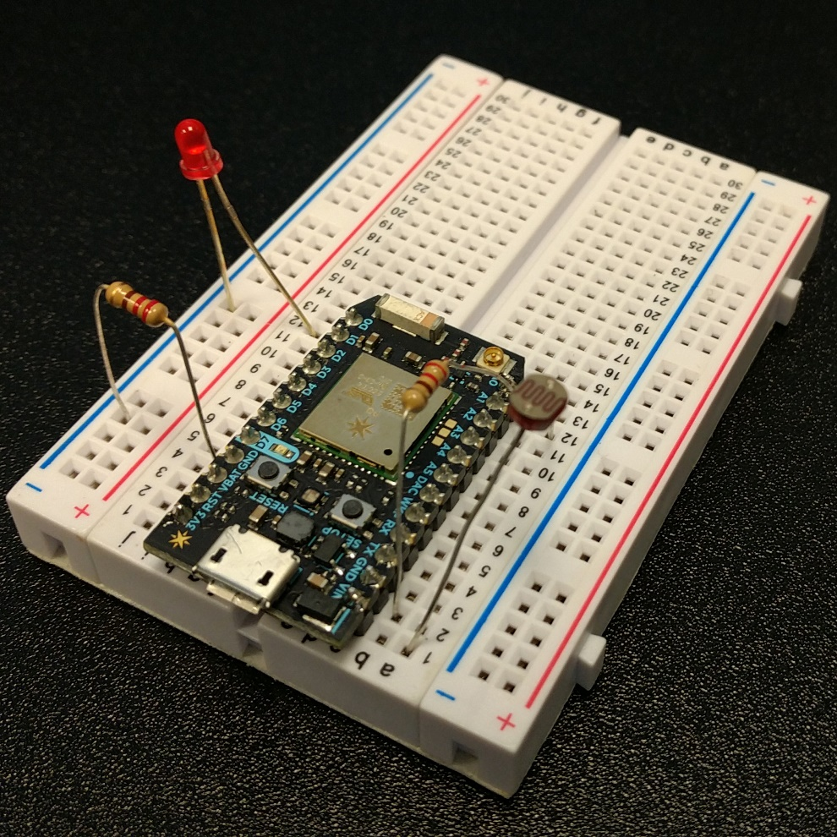

## Step 6

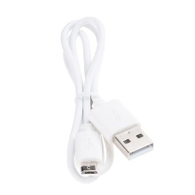Connect one end of the USB cable to the Photon device and the other end to your computer.

## Step 7

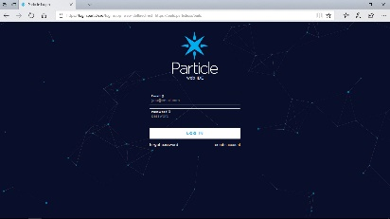Open your browser and navigate to <https://build.particle.io>. If not already logged in, enter the credentials given to you at the beginning of the session or ask one of the helpers to log you into the developer portal.

## Step 8

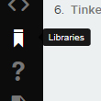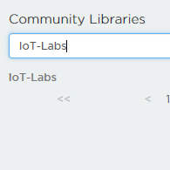Select the **Libraries** icon from the menu down the left side. In the search box enter **IoT-Labs** and click the **IoT-Labs** library link under the search box.

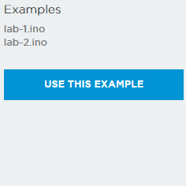Next click **lab-01.ino** from in the Examples section and then select the **Use this Example** button.

## Step 9

With the code loaded in the editor pane click the **Flash** icon (lightning bolt in the upper left corner) to send the code to your device.

## Step 10

The LDR sensor detects the amount of ambient light in the room and turns the LED on when it is dark. Test the circuit by covering the LDR with your hand or some dark object. When covered, or when it is dark, the LED should turn on. When light is present, the LED should turn off.

The amount of light needed to turn the LED on and off is based on a threshold defined in the application.

The LDR and resistor make up what is called a **voltage divider** circuit. When the light varies the voltage on pin **A0** varies. The software reads this voltage from the analog port as a value between 0 and 4096. In the application, there is a variable called **LIGHT_THRESHOLD** that determines when to turn the LED on. As light decreases, the voltage drops. This results in a lower value on the **A0** pin. The code reads the value on **A0**, compares it to the threshold and turns the LED on by setting the output of port **D0** to **HIGH**. The overall effect of comparing the voltage to the threshold is called **sensitivity**.

Locate the LIGHT_THRESHOLD variable in the code and change the value to see the effect of differing levels of sensitivity (the default value is 150). Don’t forget to flash the code to your device each time you change the value.

# Lab 2

The goal of this lab is to interact with your device via a mobile application.

## Step 1

The circuit for Lab 2 is the same circuit used in Lab 1.

## Step 2

Follow the directions in **Lab 1**, **Step 8** to load the second example application called **lab-2.ino**.

## Step 3

With the **Lab 2** code loaded in the editor pane click the **Flash** icon to send the code to your device.

## Step 4

Launch the mobile application on your mobile device and select your device in the list.



## Step 5

Click your device in the mobile application. The first screen you see is the called **Tinker**. This screen shows a picture of your device and all of the pins.

## Step 6

Click the **D0** pin.



## Step 7

Click **digitalWrite** (red bar). The pin will either show **LOW** or **HIGH** depending on the state of the LED. Click the **D0** button repeatedly to turn the LED on and off.

 

You will notice a short delay each time because your mobile application is communicating to your device over the Internet through a Cloud service call **Particle Cloud**.

## Step 8

Select the **A0** button.

## Step 9

Select **analogRead** (green bar).



## Step 10

The application will show the last value read from the analog port which is connected to the LDR on your circuit. To refresh the value, press the **A0** button repeatedly. Vary the amount of light on the sensor by either covering it up with your hand or shining light from the mobile device (using the flashlight application). While doing this, refresh the value in the mobile application.



## Step 11

Select the **Inspect** link at the top of the application.

## Step 12

Select the **Data** tab.



## Step 13

Expand the **setThreshold** function.



## Step 14

In the previous lab, you had to change the light threshold value in the code and then push or flash the code to your device each time. With the device cloud connected, this value can be updated through your mobile application.

Enter different numbers in the “**arguments”** textbox and click the **Send** button to update your device.



## Step 15

Select the **Events** tabs. This screen shows messages being published from your device to the cloud.

## Step 16

Each time the sensor turns the LED on or off an event is sent.

Examine the code to see how this works. Hint: look for a “publish” command.

Cover the sensor with your finger to make the LED turn on. You will see a message on your mobile device within a few seconds.



## Step 17

Go back to the **Data** tab in the mobile application.

## Step 18

Expand the **digitalwrite** function.

In the arguments text box enter **D7=HIGH** ensuring that all characters are upper case and there are no spaces. Select **Send**.



There is a small built-in blue LED on the board next to pin **D7** which should now be on.

## Step 19

In the arguments text box enter **D7=LOW** ensuring that all characters are upper case and there are no spaces. Select **Send**.



The built-in LED is now off.

Mobile applications can be built to interact with these devices in many ways to control all sorts of sensors.

This is how IoT devices work today.

# Lab 3

The goal of this lab is to connect your device to other devices using a service called IFTTT (if this then that).

## Step 1

This lab will use the same circuit as the previous labs and the application from Lab 2.

Open your browser and go to [**https://www.ifttt.com**](https://www.ifttt.com).

## Step 2

Click the **New Applet** button.

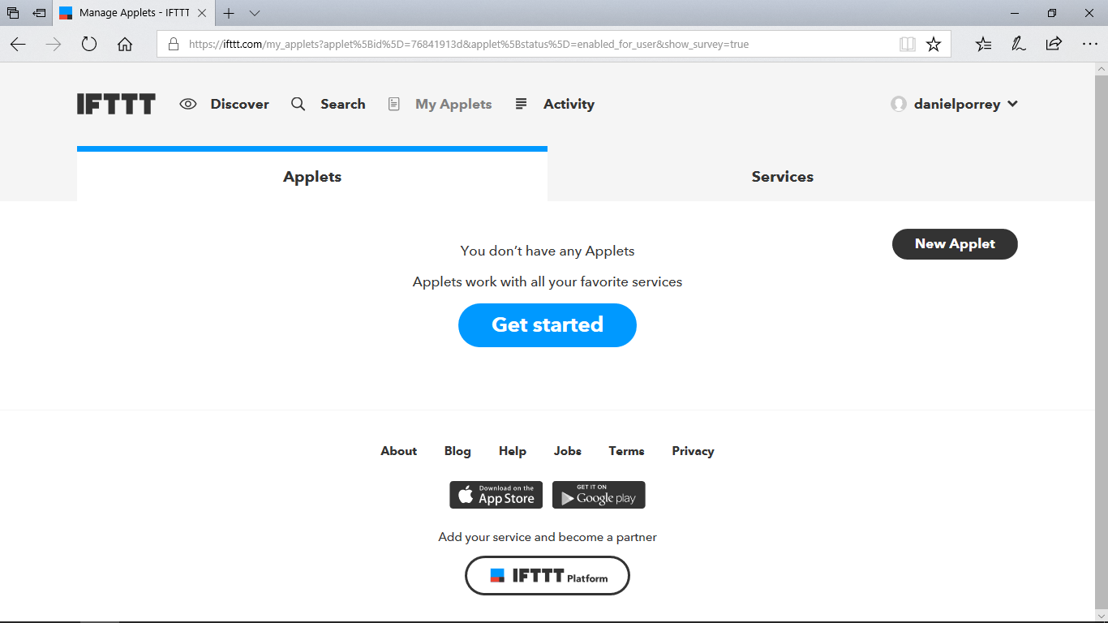

## Step 3

Click **+this** link.

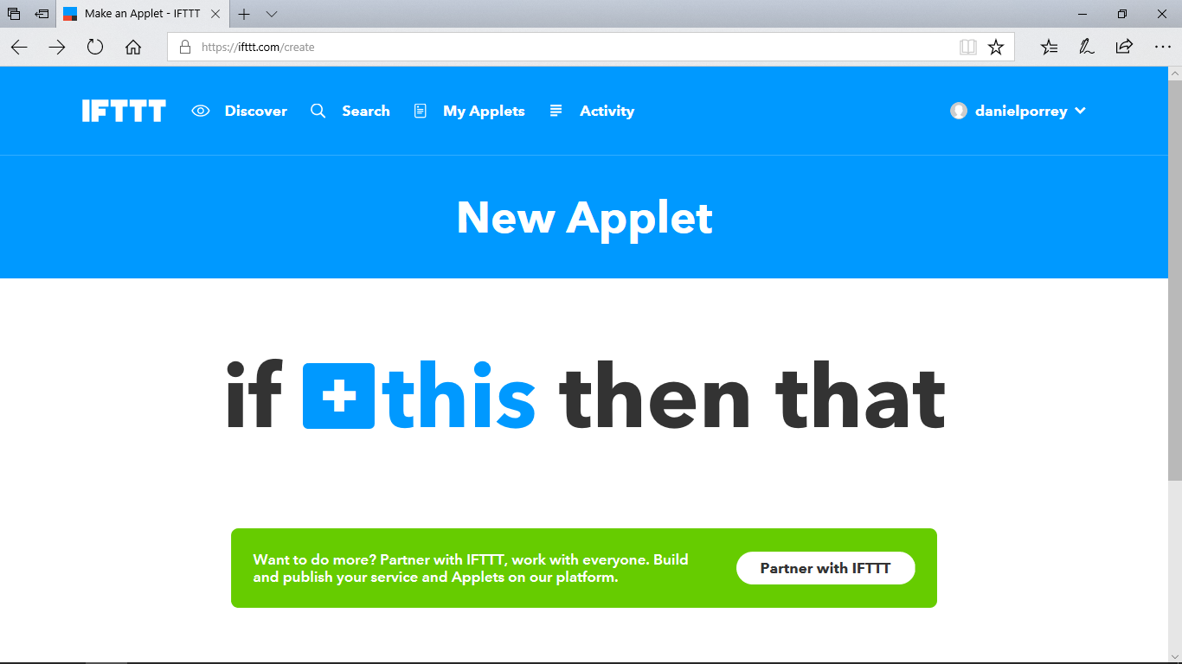

## Step 4

Enter **Particle** in the search text and then select the **Particle** button.

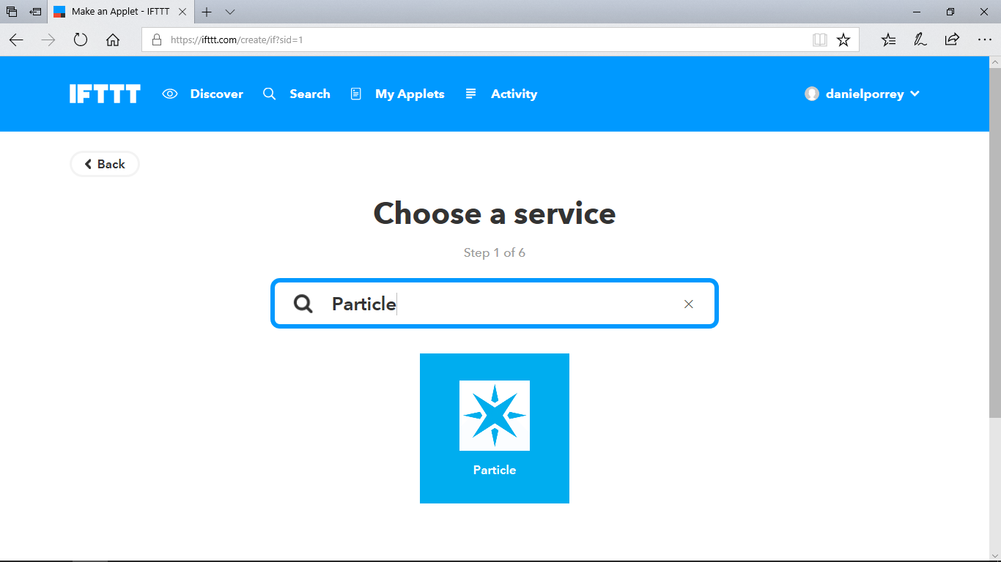

## Step 5

As a trigger, select **New Event Published**.

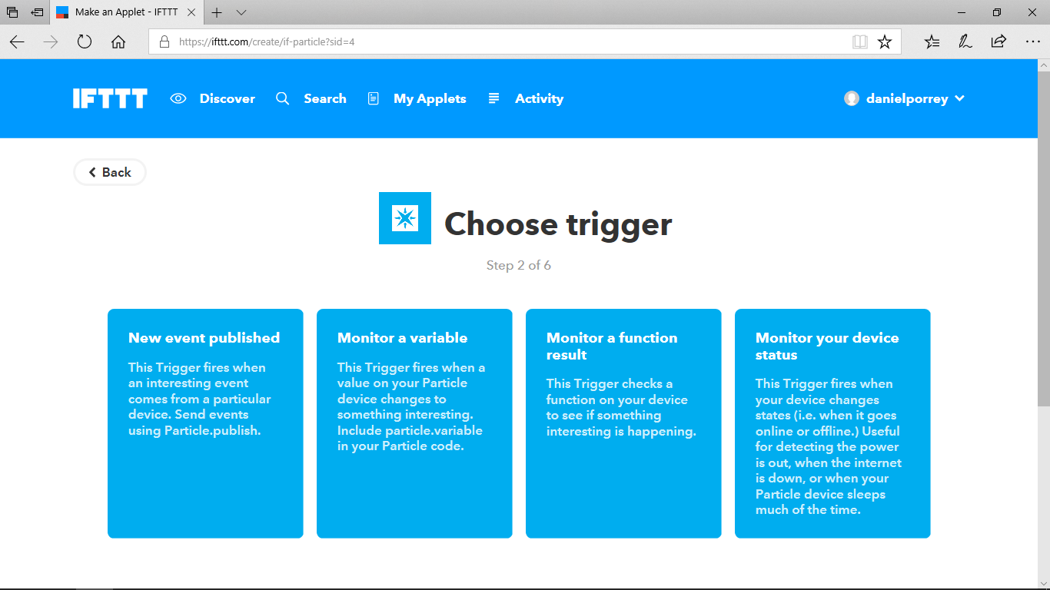

## Step 6

Enter **LED** as the event name, **on** as the data and select your device from the list.

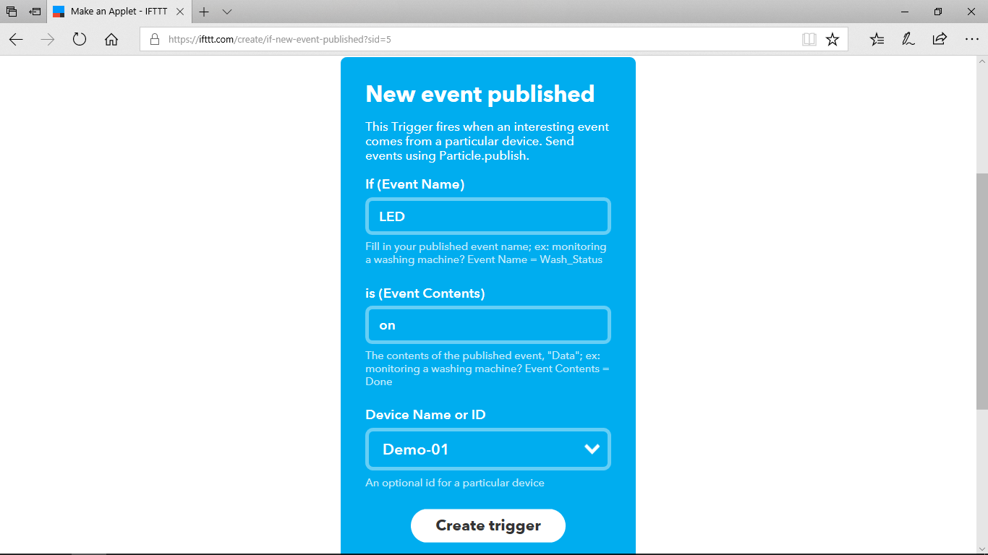

## Step 7

Click **Create Trigger**.

## Step 8

Select the **+that** link.

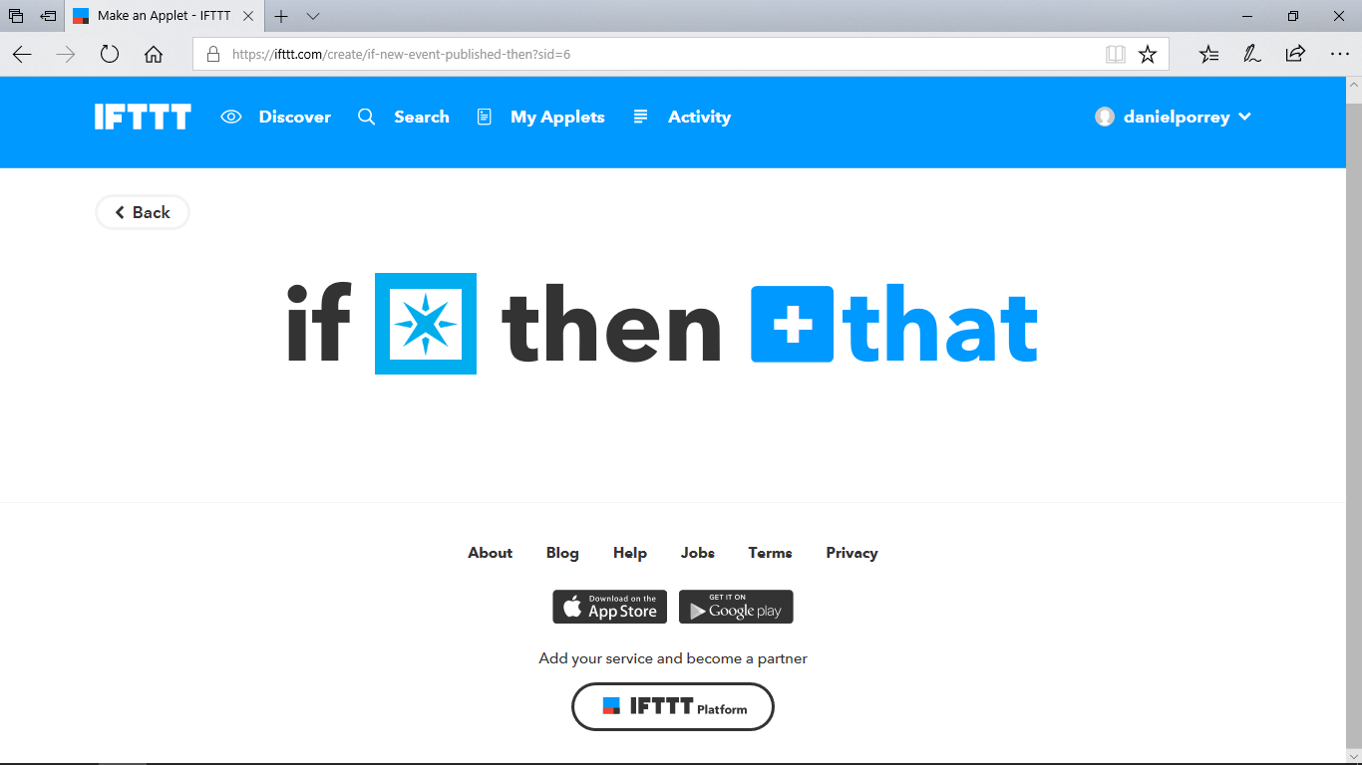

## Step 9

Enter **Email** in the search text and then select the **Email** button on the left.

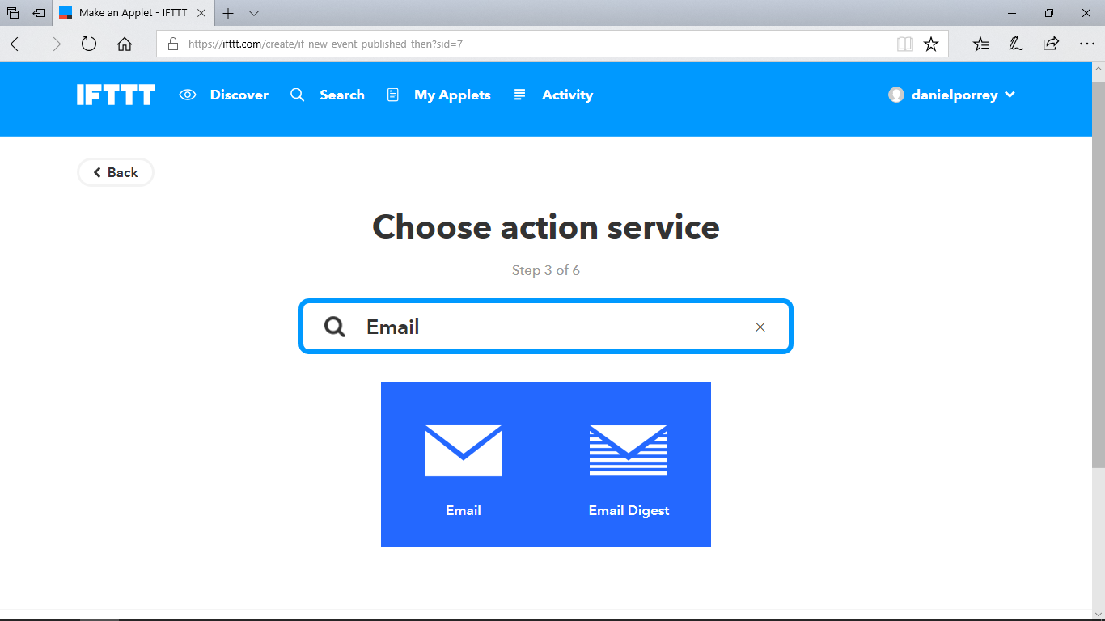

## Step 10

Choose **Send me an email** as the action.

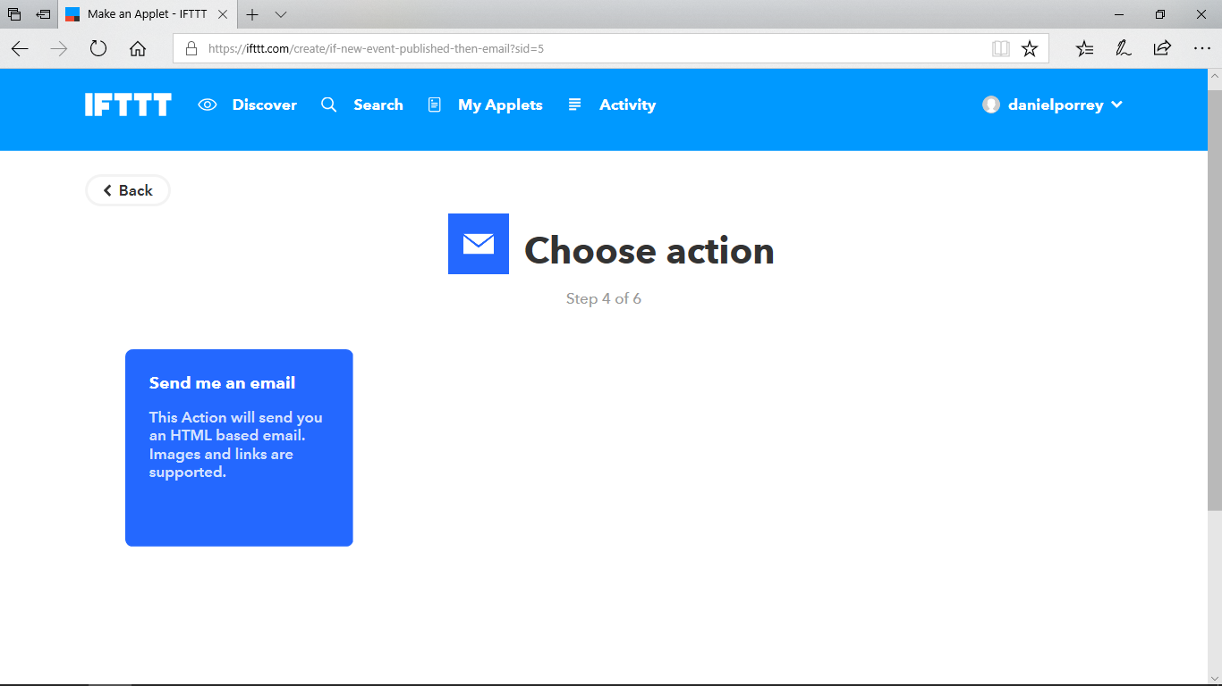

## Step 11

In the subject, type “**Night light Turned On**”. In the body enter “**The nightlight was turned on because it is dark in the room.**”

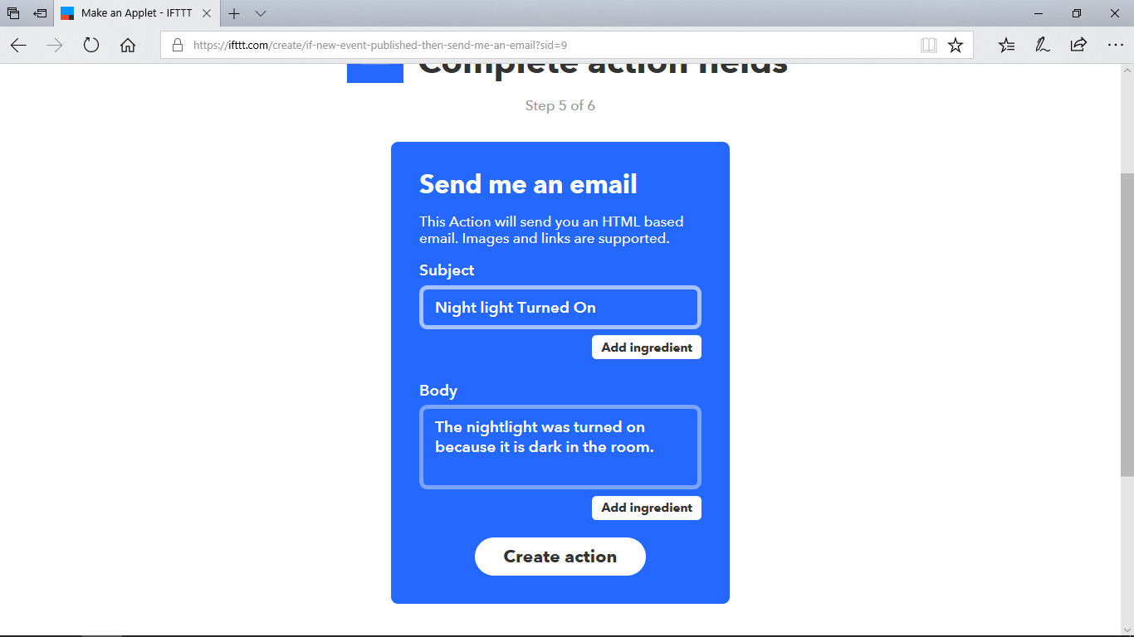

## Step 12

Click **Create Action**.

## Step 13

Click **Finish**.

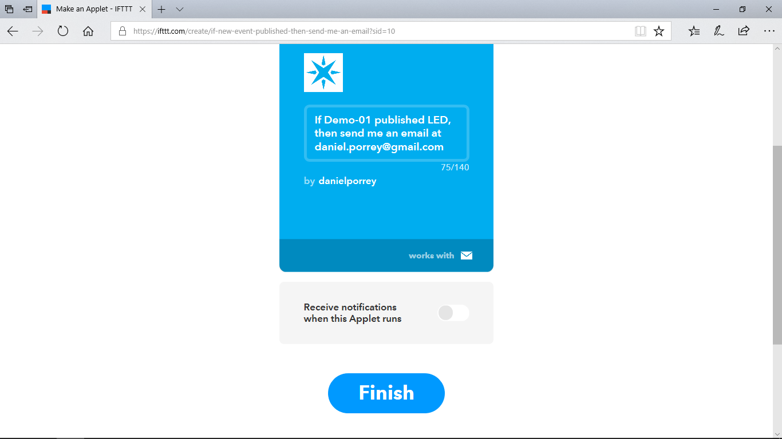

## Step 14

The IFTTT **Trigger** and the associated **Action** are now complete and are running. If your cover the sensor to trigger the LED an email will be sent to the address used in this demo.

Open the Windows Email application on the laptop to view the email. Note that in some cases it could a few minutes to receive the email.

## Step 15

If you have time, explore the IFTTT web site to see other options that may be available for your device.

## Step 16

Examine the source code in Lab 2 to try to understand some of the elements and figure out how it works.

## Step 17

Explore the mobile application further.